**The 10 Best Data Visualizations of 2022**

**Awesome visualizations on the Ukraine War, Inflation, and more!**

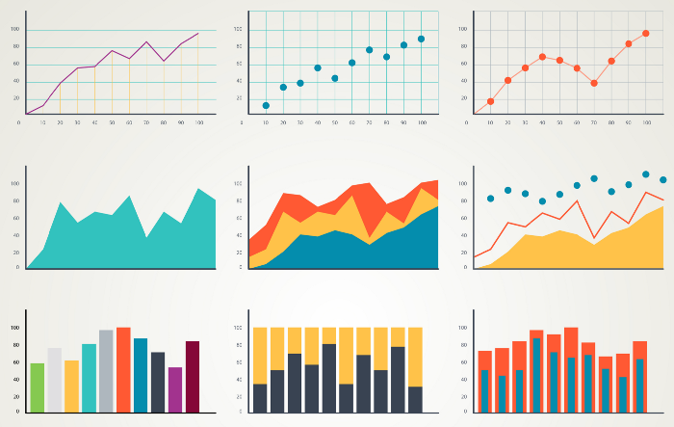

Image by svstudioart on Freepik

Last year I shared what I thought were [ten of the best data visualizations from 2021](https://towardsdatascience.com/the-10-best-data-visualizations-of-2021-fec4c5cf6cdb). I’m back again with ten of the best data visualizations from 2022!

Similar to last year, I wanted to share a variety of types of data visualizations, and also ones that were…

Let’s dive into it!

***Be sure to*** [***SUBSCRIBE here***](https://terenceshin.medium.com/membership) ***to never miss another article on data science guides, tricks and tips, life lessons, and more!***

**1. NATO vs Russia**

One of the biggest events this year was the war between Russia and Ukraine. Comforting or not, [the infographic above](https://www.reddit.com/r/dataisbeautiful/comments/t2xs7q/oc_a_comparison_of_nato_and_russias_military/) shows the difference in military power between NATO and Russia. The actual data can be found [here](https://www.statista.com/statistics/1293174/nato-russia-military-comparison/).

I love this infographic, it’s many pictographs combined into one, it’s clean, and it’s very clear what message it’s trying to convey.

NATO out-powers Russia in every aspect other than Nuclear Weapons… I wonder how this would change if Russia’s budget towards nuclear weapons went to other things 🤔.

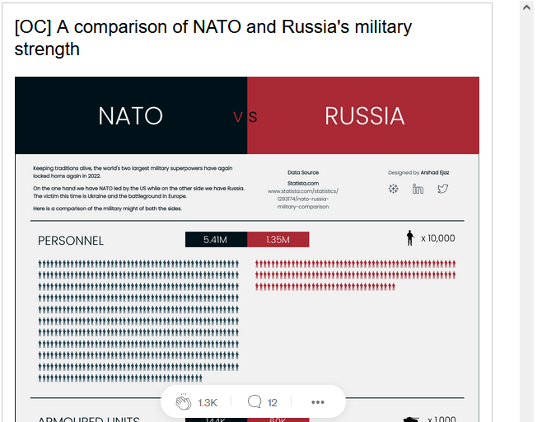

**2. Inflation and the cost of everyday items**

One of the consequences of the war between Russia and Ukraine is inflation. If you [click on the visualization](https://www.reddit.com/r/dataisbeautiful/comments/vhciop/oc_inflation_and_the_cost_of_every_day_items/) above, you’ll see how inflation has impacted our cost of everyday items, like gas, coffee, and corn. (On the bright side, the cost of orange juice went down!)

If you’re interested, this type of data visualization is similar to a **bar chart race**, which is a dynamic bar chart shown over a period of time. If you want to build one yourself, [here’s a tutorial](https://towardsdatascience.com/step-by-step-tutorial-create-a-bar-chart-race-animation-da7d5fcd7079) that you can check out.

***You can create your own visualizations today on*** [***Saturn Cloud***](https://saturncloud.io/?utm_source=Medium+&utm_medium=TDS&utm_campaign=Terence+Shin&utm_term=10-best-data-visualizations-of-2022)**!**

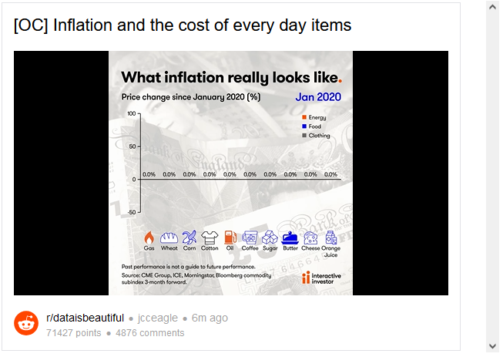

**3. More on inflation and wages!**

Everyday items aren’t the only things affected by inflation, wages are also impacted by inflation. What does this mean? As inflation increases, the value of the dollar decreases, meaning our dollar doesn’t go as far as it used to.

[This visualization](https://www.reddit.com/r/dataisbeautiful/comments/suqj9n/oc_us_wages_are_now_falling_in_real_terms/) is a dynamic line chart that shows how wage growth and inflation have changed since 2015. In 2021, for the first time since 2015, inflation surpassed wage growth.

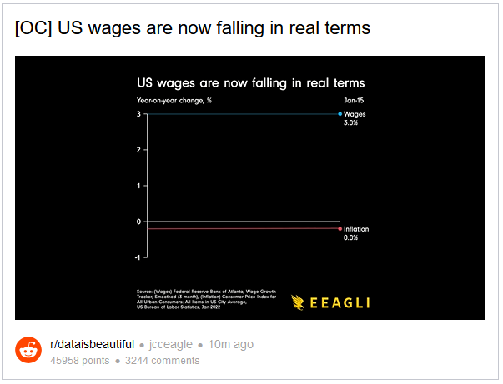

**4. School Shootings**

Sometimes, a static bar chart is all you need to convey a message. [This visualization](https://www.reddit.com/r/dataisbeautiful/comments/x5m70v/oc_countries_with_school_shootings_total/) shows the number of school shootings by country from 2009 to 2018. If this doesn’t imply that the US has a gun problem, I don’t know what does!

*FYI, the US has* ***48 times more*** *school shootings than the second highest country… forty eight!*

***Be sure to*** [***SUBSCRIBE here***](https://terenceshin.medium.com/membership) ***to never miss another article on data science guides, tricks and tips, life lessons, and more!***

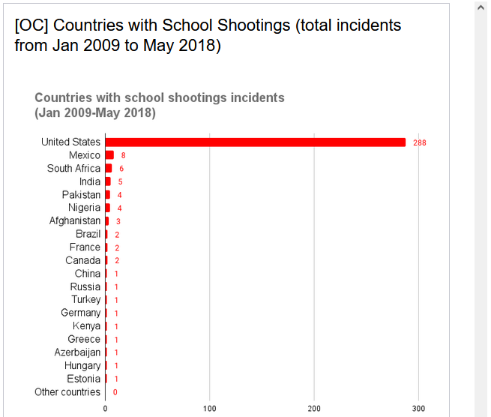

**5. What are people studying in school?**

While we’re on the topic of school, [the image above](https://www.reddit.com/r/dataisbeautiful/comments/xc4ckq/oc_fastest_growing_and_shrinking_us_college/) shows the fastest growing and shrinking fields of study in US colleges. STEM fields seem to make up the fastest-growing fields, while arts and history fields seem to make up the fastest-shrinking fields.

This data was provided by the U.S. Department of Education.

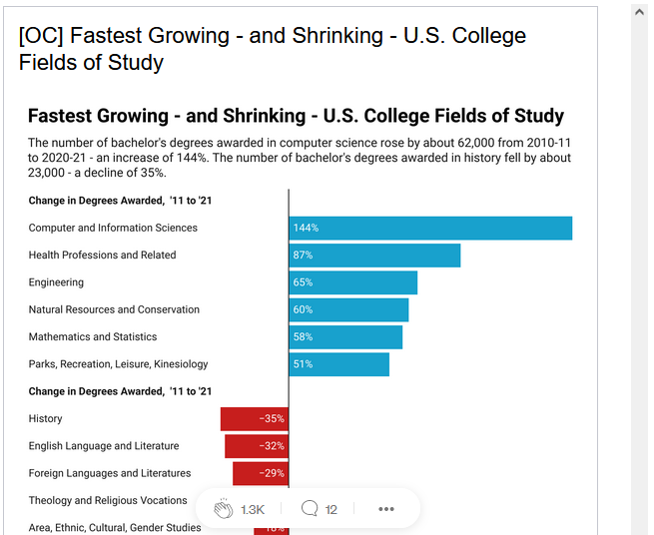

**6. Time it takes for a hacker to brute force your password in 2022**

Ever wonder why certain websites require a variety of characters and a minimum number? [This visualization](https://www.reddit.com/r/dataisbeautiful/comments/ifral7/oc_time_it_takes_to_crack_a_password_updated/) shows the time that it takes a hacker to brute force your password in 2022.

What makes this visualization so powerful is how comprehensive it is — part of this is attributed to the colour scheme depending on how long it takes to brute for the password.

The data was compiled from [How Secure is My Password](https://www.security.org/how-secure-is-my-password/) and this was built using Illustrator and Excel.

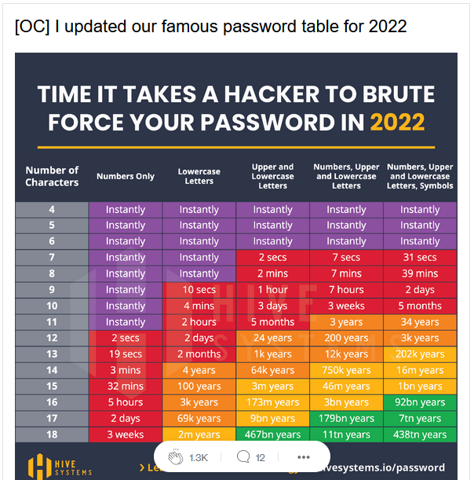

**7. Most popular web browsers over the last 28 Years**

Now for the “Most Popular” visualizations of the year, [this visualization](https://www.reddit.com/r/dataisbeautiful/comments/v3c9nv/oc_web_browsers_over_the_last_28_years/) shows the most popular web browsers over the last 28 years! As of March 2022, it’s no surprise that Google Chrome takes 80% of the market share, but that wasn’t the case back in the day.

This type of visualization is called a pie chart race, and it serves a similar purpose as a bar chart race, except that it’s more useful when you’re trying to emphasize proportions as opposed to absolute numbers.

The data used to build this was taken from the following sources:

* W3Schools (Jul-99 to present)
* WebSideStory (Feb-99 to Jun-06)
* GVU WWW user survey (Jan-94 to Oct-98)
* EWS Web Server at UIUC (Jun-96 to Dec-98)

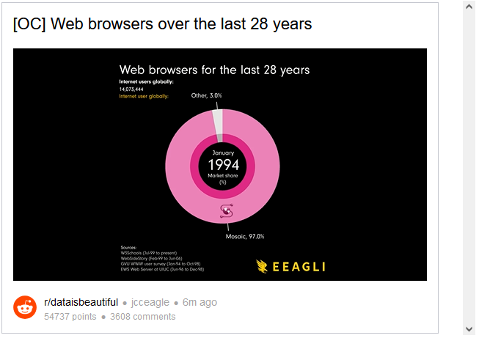

**8. Most Popular websites since 1993**

The most popular web browsers are one thing, but the most popular websites are another. [This visualization](https://www.reddit.com/r/dataisbeautiful/comments/vbw2y7/oc_most_popular_websites_since_1993/) shows the most popular websites since 1993. What’s surprising is that Yahoo is still the ninth most visited website as of January 2022!

This type of data visualization is called a **bar chart race.** I’m sure you’ve seen many of these all over YouTube and Reddit.

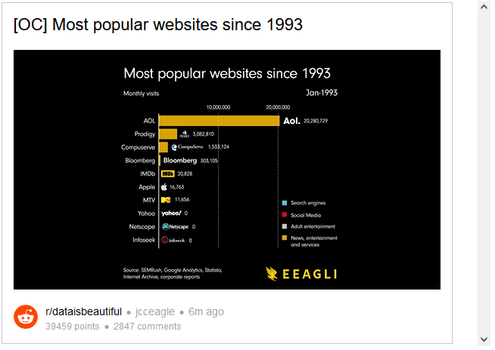

**9. Most spoken languages in the world**

Another simple yet powerful visualization, [this bar chart](https://www.reddit.com/r/dataisbeautiful/comments/t5oitk/most_spoken_languages_in_the_world_oc/) shows the most spoken languages in the world, with the top three being English, Mandarin, and Hindi.

This visualization was created using ggplot in R with data provided by [Wikipedia](https://en.wikipedia.org/wiki/List_of_languages_by_total_number_of_speakers).

***You can create your own visualizations using ggplot on SaturnCloud*!**

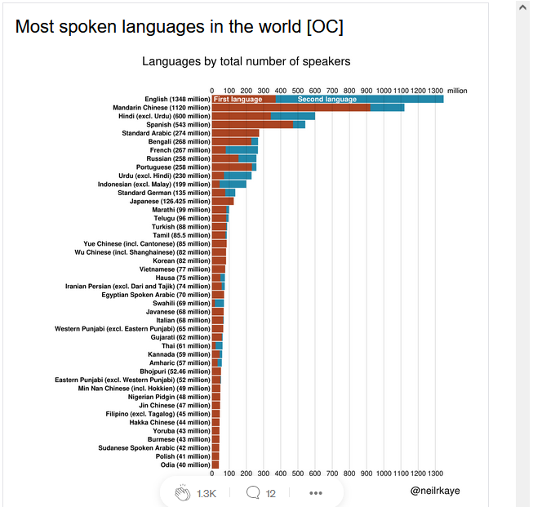

**10. Biggest Fast Food Chains**

For the last article, [this visualization](https://www.reddit.com/r/dataisbeautiful/comments/xaqfxx/oc_50_biggest_fast_food_chains_by_2021_number_of/) shows the top 50 biggest fast food chains based on the number of stores in the US. You can see that it’s split by “food category”, and within each category, the size of each restaurant represents its magnitude.

Who know that there were more Subways and Starbucks than McDonalds?

This visualization is called a treemap and is typically used when you want to visualize hierarchical and partitioned data. If you want to learn how to build one in Python, check out this [link](https://plotly.com/python/treemaps/).

